**PCBPT UIST 023 Demo Floor plan**

Fangzheng Liu

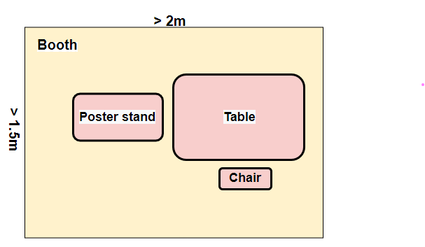

**- size of the booth:** > 2m x 1.5m  
**- demo hardware components:** PCBPT machine (put on table), a monitor (preferred 27in, 24in works, too), a laptop (brought by myself)  
**- numbers of tables:** 1  
**- chairs:** 1  
**- light or dark environment required:** light environment  
**- power requirements:** an power extension cord with at least 2 outlets  
**- VR setup:** None  
**- poster stand (recommended):** yes  
**- any other equipment or relevant detail:** none